Supplementary S5. Terminology mapping and keyword co-occurrence analysis used to refine the PICO search strategy for mHealth security requirements from Scopus 2010 to 2025 year with VOSviewer v1.6.20.
This supplementary file documents the data source, sampling rationale, cleaning rules, VOSviewer configuration, and outputs including the keyword co-occurrence map and the derived wildcard noun set used across the four search domains.

S5.1 Purpose
This supplementary file reports the terminology mapping step used to reduce the risk of a possible incomplete or biased keyword set for the literature search on security requirements within the mHealth domain. The keyword co-occurrence analysis was used exclusively to (i) harmonize terms, (ii) remove clearly irrelevant generic terms, and (iii) derive wildcard nouns that informed the final PICO query formulation across four search domains. The resulting co-occurrence map is provided as Figure S5.1.

S5.2 Data source and corpus definition
We used Scopus as the bibliographic source to build a broad terminology corpus related to security in the health domain. The corpus was retrieved using the following query:
TITLE-ABS-KEY ( security AND health )
The time window was no restricted to 2010–2025. This corpus was used for terminology discovery to support query refinement and reduce the risk of omitting commonly used terms in the target research space.
Sampling rationale. Due to limitations in exporting records from Scopus, the keyword co-occurrence analysis was performed using the last 20,000 most cited records from the retrieved full corpus, which was n = 99,384. This sampling approach was used as a practical indicator for the discovery and grouping of frequent terms, rather than as an inferential estimate of the full corpus.

S5.3 Keyword extraction and occurrence thresholding
Keywords were obtained from the Scopus export and aggregated into an initial candidate set for mapping. To focus on stable and recurring concepts, we retained terms meeting the following frequency rule:
- Minimum occurrence threshold: at least 55 occurrences in the 20,000-record sample.
This threshold was used to reduce noise from rare or idiosyncratic descriptors while retaining commonly encountered terminology.

S5.4 Cleaning and harmonization rules
Before generating the co-occurrence map, the authors harmonized terminology to reduce redundancy and remove obvious noise based on them expertise. The following cleaning rules were applied deterministically:
- Synonym merging. Terms with equivalent meaning were unified into a single preferred label (e.g., consolidating “electronic medical record” and “EMR” when used to refer to the same concept).
- Abbreviation handling. Abbreviations with unambiguous meaning in context were consolidated; ambiguous abbreviations were removed to prevent conflation of different concepts.
- Removal of generic publication descriptors. Terms clearly referring to publication types or generic research discourse rather than domain content were removed (e.g., “model”, “review”, “literature review”, “survey”, “article”).
- Removal of high-frequency non-target terms. High-frequency terms that did not contribute to identifying security requirements in mHealth within this study’s scope were removed when they did not improve query specificity.
- Spelling and variant unification. Minor spelling variants, pluralization differences, and trivial lexical variants were unified.

S5.5 VOSviewer configuration
The keyword co-occurrence map was generated using VOSviewer version 1.6.20 [1] with the following settings:
- Software: VOSviewer v1.6.20
- Type of analysis: Co-occurrence
- Unit of analysis: Keywords
- Counting method: Full counting
- Minimum number of occurrences: 55
- Thesaurus file: Not used
The “Keywords” unit corresponds to the keyword fields provided by the Scopus export used in this study.

S5.6 Outputs
Figure S5.1 presents the keyword co-occurrence map derived from the Scopus sample after harmonization and filtering. The visualization was used to identify dominant clusters of terms associated with security and healthcare ICT, intersections with mHealth-relevant concepts, and candidate wildcard nouns for the final PICO-based search strategy.
Figure S5.1. Keyword co-occurrence map derived from the Scopus corpus retrieved with TITLE-ABS-KEY ( security AND health ) (2010–2025), using the last 20,000 records due to export constraints; keywords were harmonized and filtered with a minimum occurrence threshold of 55; map generated using VOSviewer v1.6.20 with co-occurrence analysis, keywords as the unit of analysis, and full counting.
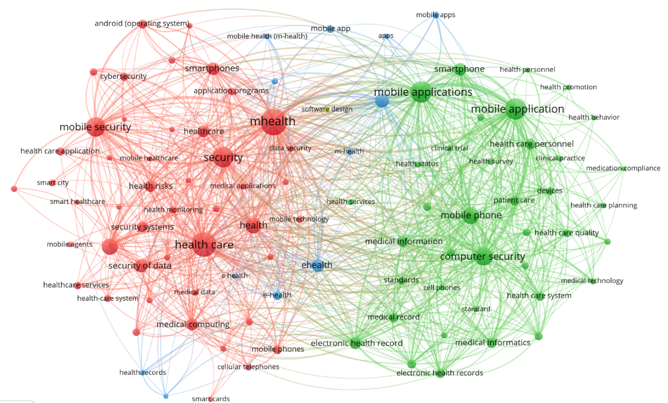

S5.7 Derived wildcard nouns for the four search domains for PICO refinement
The co-occurrence analysis supported the selection and harmonization of wildcard nouns used across the four search domains in the final search strategy. The purpose was to ensure that query terms capture common constructs associated with security implementation and security requirements in mHealth and related healthcare ICT contexts.
The wildcard noun sets were operationalized as follows:
- Domain 1: mHealth and mobile ICT context terms: mHealth*, mobile health, smartphone*, Android*, mobile app*, telehealth*, remote monitoring*, wearable*, patient portal*, personal health record*.
- Domain 2: security requirements and controls terms: security requirement*, requirement specification*, security control*, confidentiality, integrity, availability, access control, authentication, authorization, cryptograph*, secure storage, encryption, key management, secure communication, secure session*, audit trail*.
- Domain 3: implementation, governance, and assurance terms: DevSecOps, CI/CD, secure SDLC, audit*, compliance, policy, privacy, regulation, governance, risk management, vulnerability management.
- Domain 4: evaluation and verification terms: assessment, verification, validation, test*, static analysis, dynamic analysis, penetration test*, vulnerability, risk, mitigation, evidence.
This terminology refinement step guided the formulation of wildcard nouns incorporated into the final PICO inquiry and served as an internal control to reduce missed-term risk.

S5.8 Notes on interpretation and limitations
This co-occurrence analysis was conducted to support terminology discovery and query refinement only. The output should not be interpreted as a bibliometric or scientometric analysis of the security-and-health literature. The use of the last 20,000 records was driven by export constraints and was considered adequate for identifying high-frequency recurring terms to inform the search strategy.

References
[1] N. J. van Eck and L. Waltman, “Software survey: VOSviewer, a computer program for bibliometric mapping,” Scientometrics, vol. 84, no. 2, pp. 523–538, 2010, doi: 10.1007/s11192-009-0146-3.

https://url-shortener.me/AA82

